**CSE 499A (Section 4)**

**Design Report (CO2)**

**Project Title:** Plant Diseases Detection Using Image Processing

**Submitted To**

**Dr. Shazzad Hosain (SZZ)**

**Date: 5/12/2024**



**Semester: Summer 24**

**Group No: G-3**

**Group Members**

|  |  |
| --- | --- |
| **ID** | **Name** |
| 2011892042 | Akib Hasan |
| 2012464042 | Abroor Zahin Niloy |
| 2011566042 | Tania Akter Lima |
| 2012959042 | Naima Homaira Khan |

1. **Use Case Diagram**

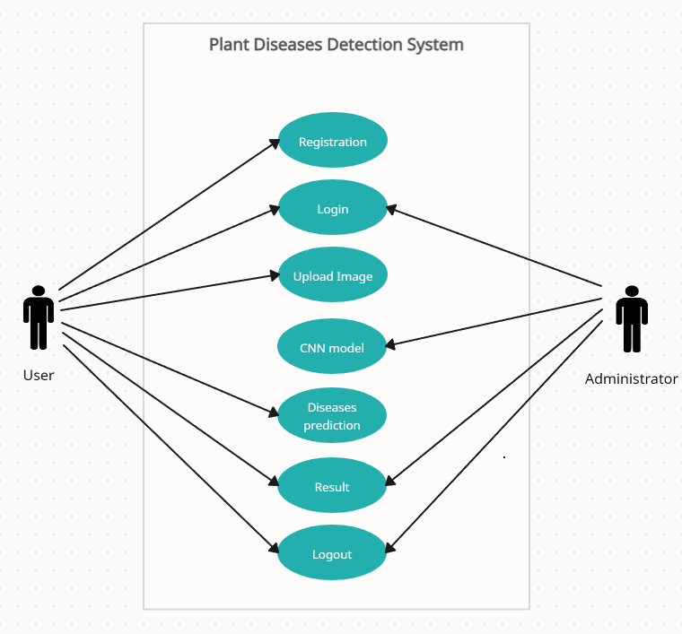

1. **UX Designs**

**Registration:**

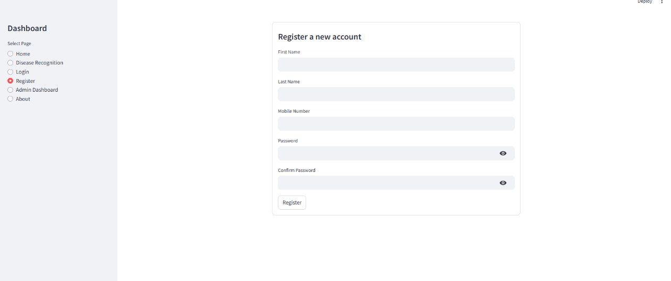

**Login:**

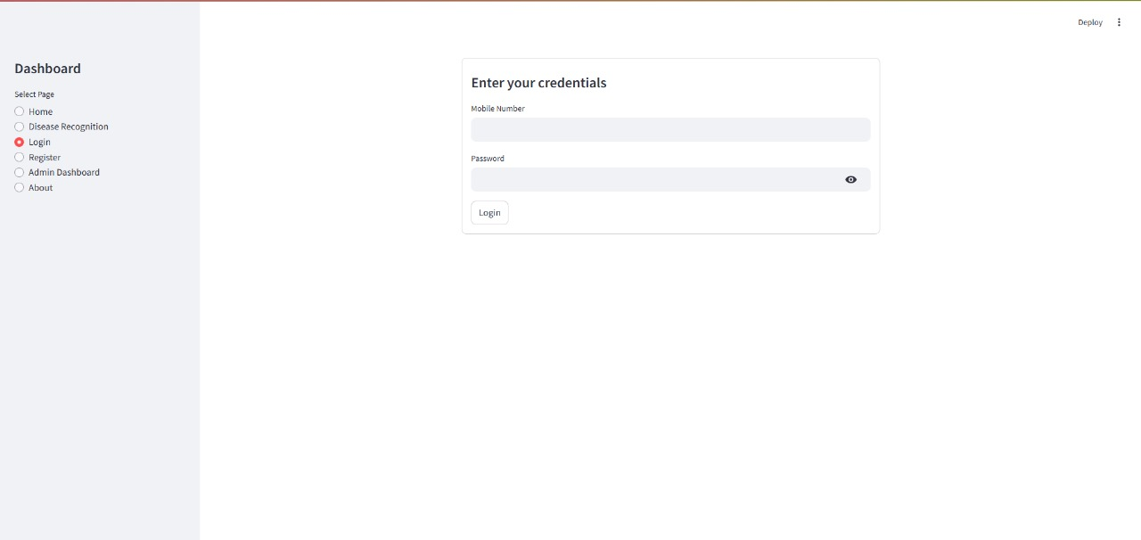

**Disease recognition:**

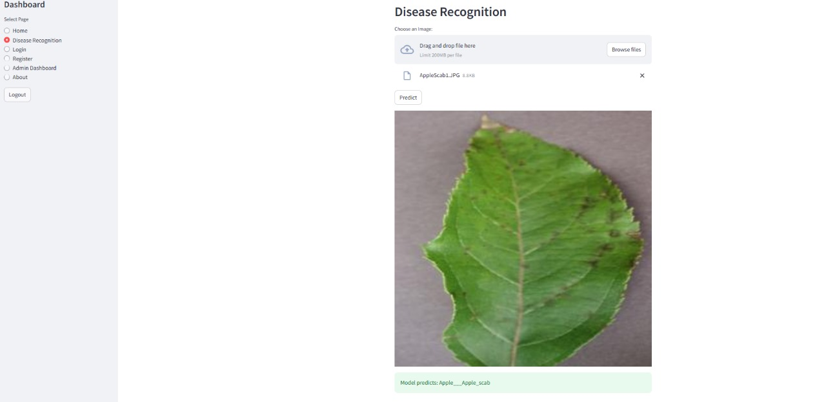

1. **System Designs**

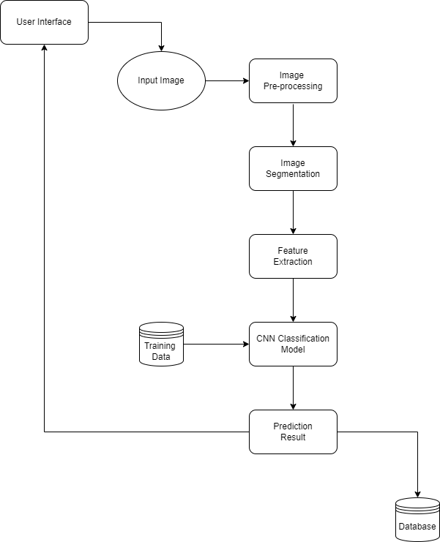

1. **Database design / Hardware Component Description**

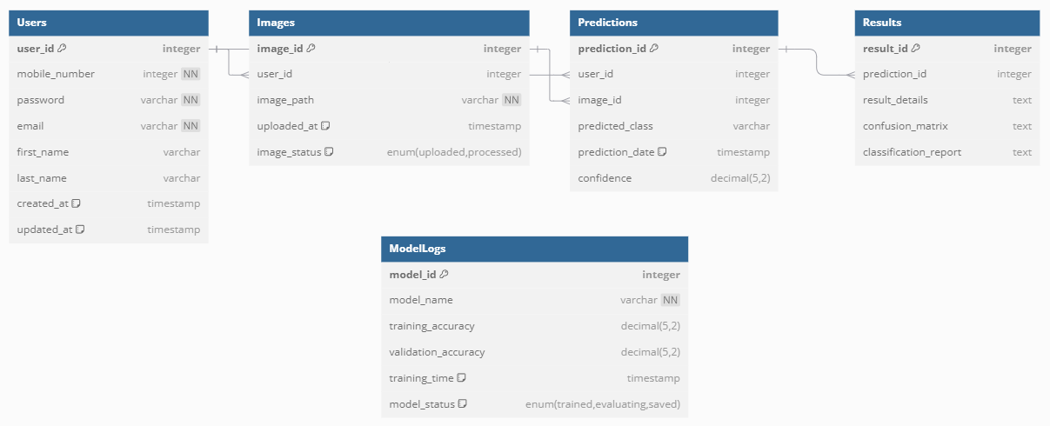

1. **Class diagram**

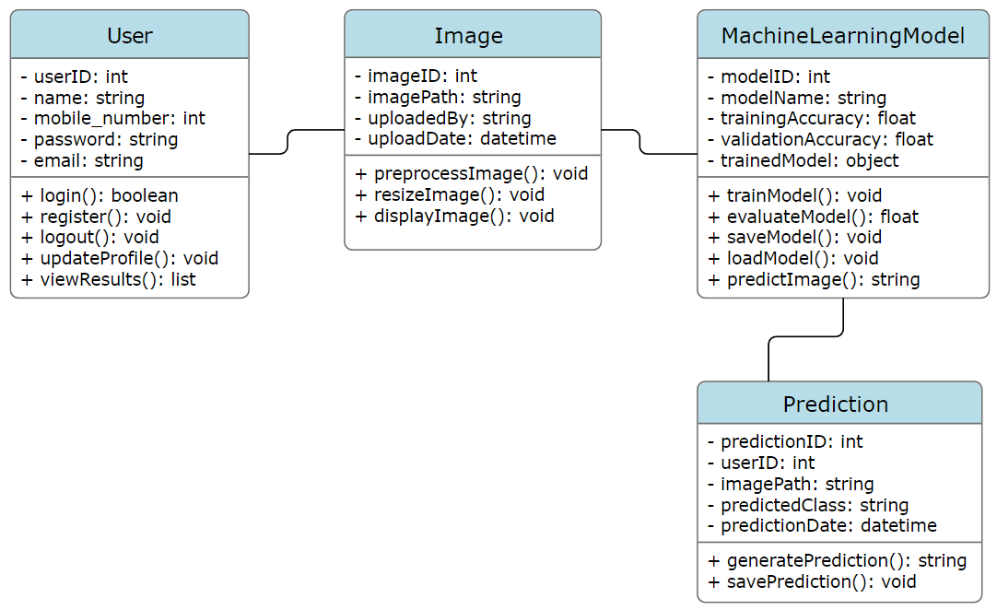

**sequence diagram**

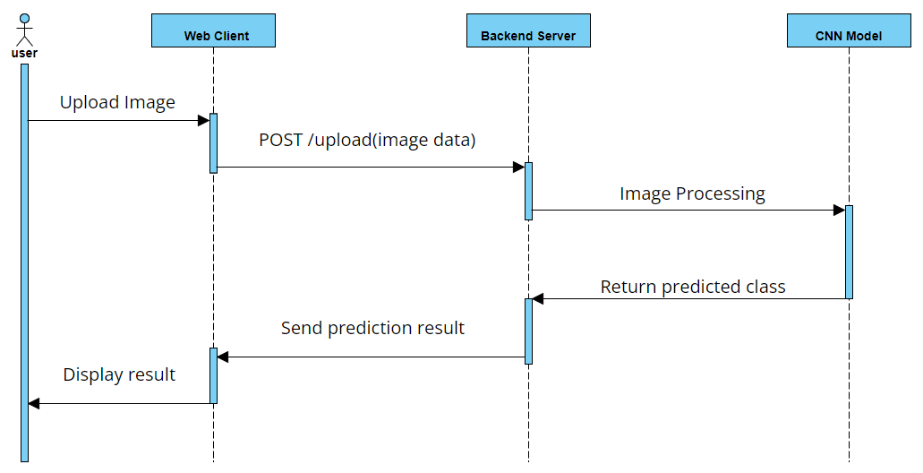

1. **Relevant equations and algorithms**

* **Preprocessing:**

**Image Resizing**: Ensures all input images are uniform in size.



Implemented using libraries like TensorFlow or OpenCV (tf.image.resize or cv2.resize).

**Normalization**: Scales pixel values to the range [0,1][0, 1][0,1]:



* **Convolutional Neural Network (CNN)**

**Convolution Operation**:



**Activation Function:**



**Pooling**: Max pooling is common for reducing feature map size:



**Fully Connected Layer**: Converts extracted features into class probabilities using:



**Dropout**: Prevents overfitting by randomly zeroing ppp fraction of neurons:



* **Training**

**Loss Function**: **Categorical Crossentropy** for multi-class classification:

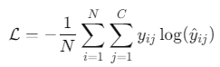

**Optimization Algorithm**: Likely **Adam Optimizer**:

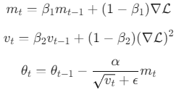

* **Evaluation Metrics**

**Accuracy**:



**Precision:**

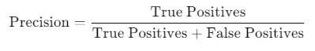

**Recall:**



**F1-Score:**

